The Analysis Report for Opening French Restaurant in Toronto

Executive Summary

Location is considered to be one of the most important factors that contribute to the success of a restaurant.

After consideration of competition, the ability to accustom to different cuisine and population, it is best to open the French restaurant in either it is best to open the restaurant in the neighbourhoods Fairview, Henry Farm or Oriole, which we can enjoy low competition, ample ability in the neighbourhoods to accustom to different cuisine and have a good population of 58,293 (2016 census).

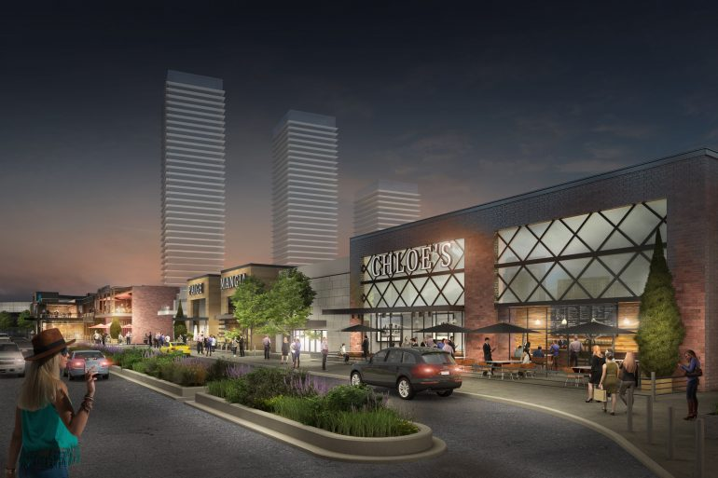

(Fairview Mall, photo link: <https://torontostoreys.com/fairview-mall-makeover/> )

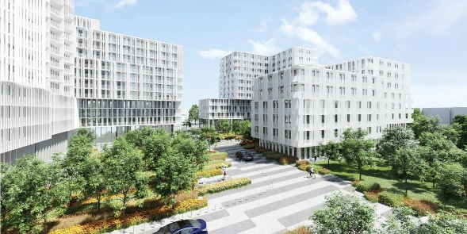

(Henry Farm Condos, photo link: <https://99homes.ca/neighbourhood/henry-farm/>)

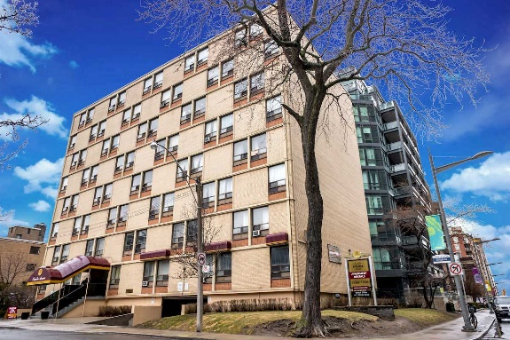

(Oriole, photo link: <https://www.caprent.com/apartments-for-rent/toronto-on/oriole/> )

Competition

From a high level perspective, we can see that the density of restaurants in the Toronto area increases closer to the airport:

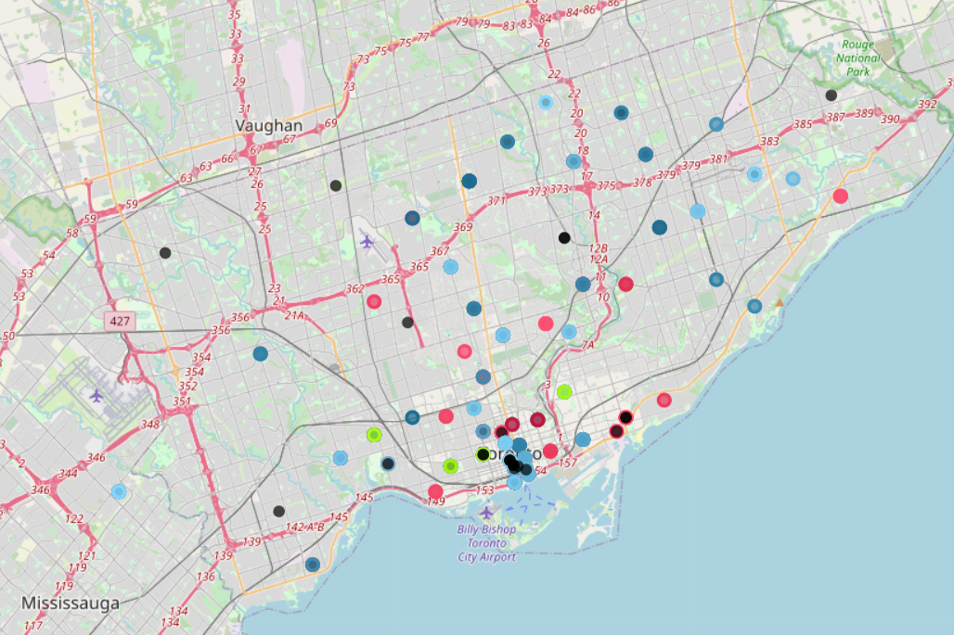

Hence, from a general point of view, the competition increases as we move towards the airport, and decreases as we move away from the airport.

There are 11 French restaurants in the Toronto area:

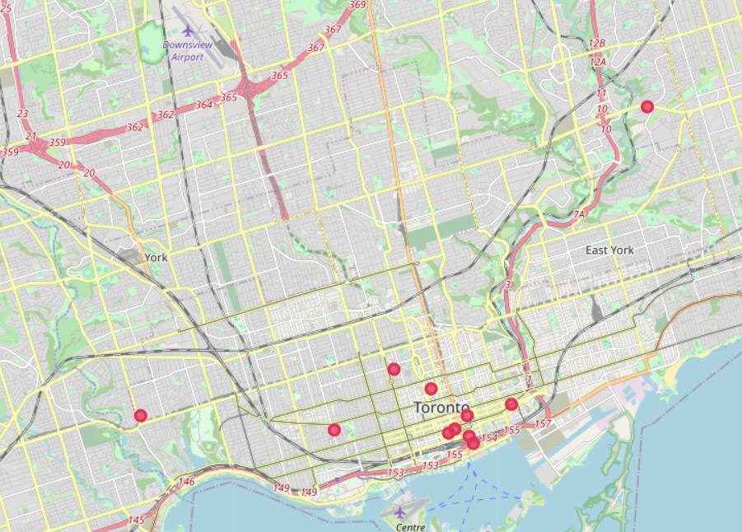

Most of them are near the airport. Hence anywhere near the airport will have a high competition in same cuisine.

Accustoming to different cuisine

After clustering, we found that Cluster 1 has the most number of Neighbourhoods hence has the largest cuisine variety. Cluster 4 has 18 Neighbourhoods, and moderate cuisine variety. Other clusters has very little cuisine variety and fewer Neighbourhoods.

If the restaurant opens near restaurants that belong to cluster 1, we expect the competition to be larger. If we open the restaurant near clusters 2,3,5, we expect low competition, but as theses Neighbourhoods are not accustomed to a large variety of cuisine, we expect introducing a new type of cuisine which is uncommon will be difficult.

Hence, opening a restaurant that is close to cluster 4 restaurants may be the better choice, since people are more accustomed to cuisine variety, and the competition is less fierce.

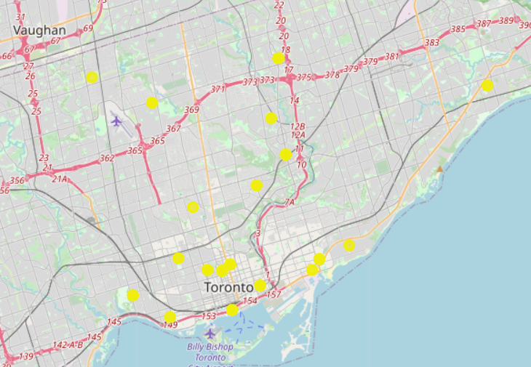

Population

As the turnover of the restaurant highly depends on the number of people, more populated areas will always have a higher chance of a larger turnover, other factors not considered.

Hence, we will want to find the most populated neighbourhood in our chosen cluster.

The population of cluster 4:

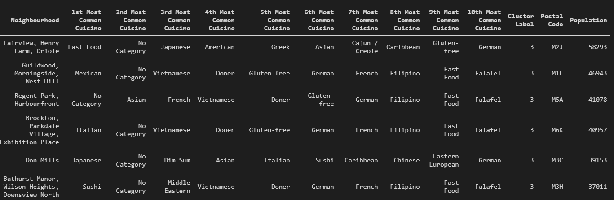

Fairview, Henry Farm and Oriole has the highest population.

Conclusion

Combining all the aspects discussed above, Fairview, Henry Farm and Oriole are far from the airport and other French cuisine competitors, people have a larger chance to accustom to different cuisine, and the highest population in the chosen cluster, they are the best choice to consider for opening a French restaurant.